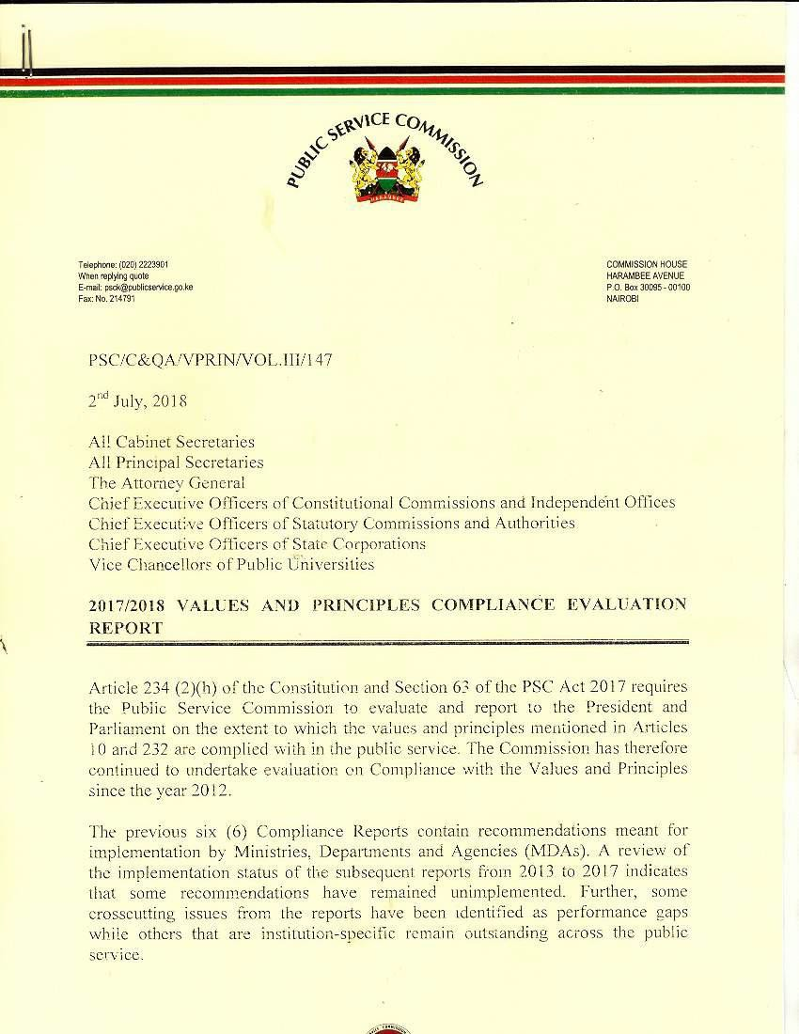

1

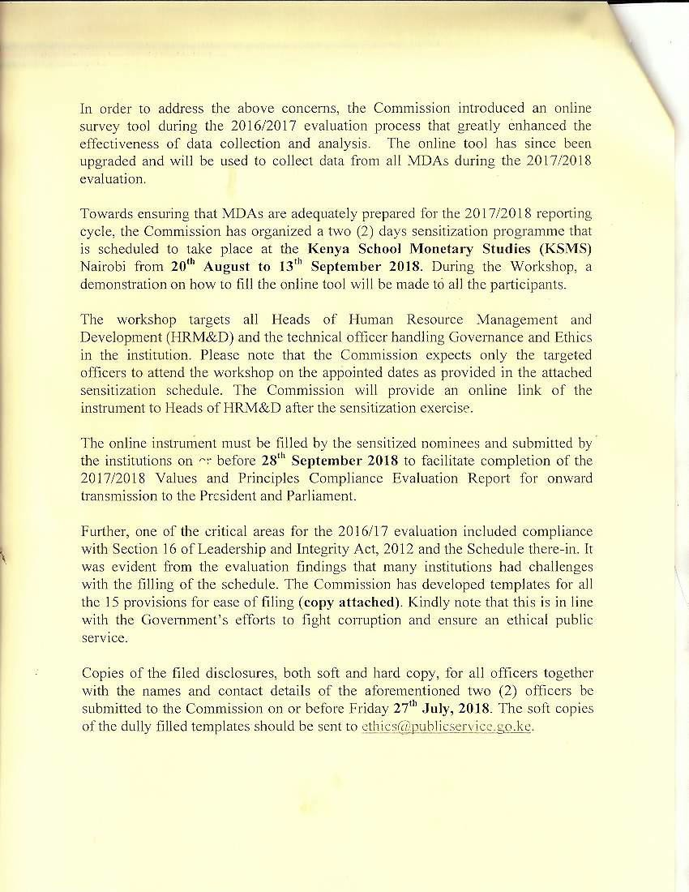

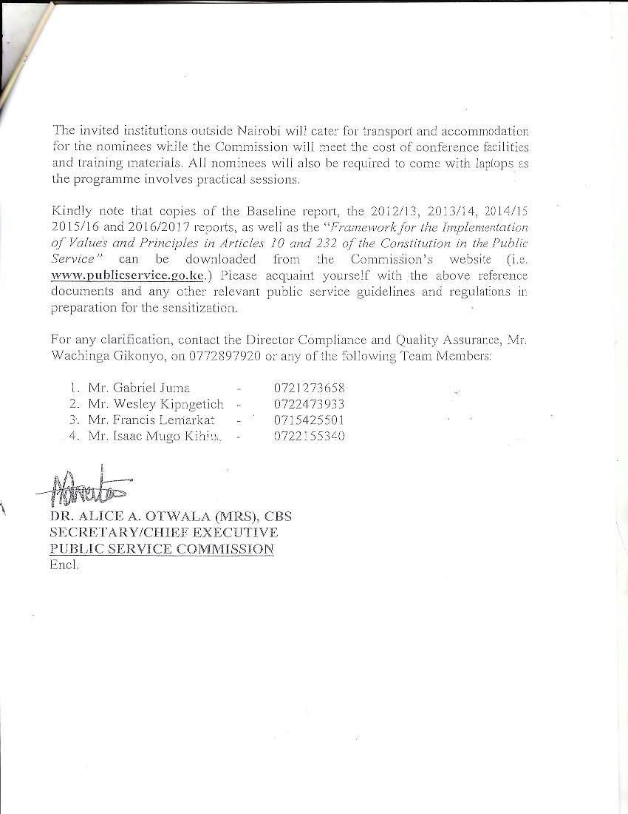

SENSITIZATION WORKSHOP ON CONSTITUTIONAL VALUES AND PRINCIPLES TO BE HELD AT THE KENYA SCHOOL OF MONETARY STUDIES (KSMS) NAIROBI - JULY AND AUGUST 2018

GROUP | DATE | NAME OF ORGANIZATION | NO. OF PARTICIPANTS | PARTICIPANT’S PARTICULARS
GROUP I | 20th – 21st August 2018 | - Alupe University College (Moi)  - Chuka University  - Cooperative University of Kenya  - Dedan Kimathi University of Science and Technology  - Egerton University  - Garissa University  - Jaramogi Oginga Odinga University of Science  & Technology  - Jomo Kenyatta University of Agriculture & Technology  - Kaimosi Friends University College (Masinde M.)  - Karatina University  - Kenyatta University  - Kibabii University  - Kirinyaga University  - Kisii University  - Laikipia University  - Maasai Mara University  - Machakos University  - Maseno University  - Masinde Muliro University of Science & Technology  - Meru University of Science and Technology  - Moi University  - Multi-Media University of Kenya  - Murang’a University of Technology  - Pwani University  - Rongo University  - South Eastern University  - TaitaTaveta University  - Technical University of Kenya  - Technical University of Mombasa  - Tom-Mboya University College (Maseno)  - Turkana University College  - University of Eldoret  - University of Embu  - University of Kabianga  - University of Nairobi  - Ewaso Ngiro North Development Authority  - Independent Policing Oversight Authority | 2 officers per institution (57x2 = 114) | One (1) Head of HR; and One (1) technical officer handling governance and ethics

GROUP | DATE | NAME OF ORGANIZATION | NO. OF PARTICIPANTS | PARTICIPANT’S PARTICULARS
- Kenya Accreditation Services
- Kenya Animal Genetic Resources Centre
- Kenya Copyright Board
- Kenya Deposit Insurance Corporation
- Kenya Film Commission
- Kenya Industrial Estate Limited
- Kenya Investment Authority
- Kenya Leather Development Council
- Kenya Meat Commission
- Kenya Medical Research Institute
- Kenya Medical Training College
- Kenya Safari Lodges and Hotels
- Kenya Yearbook Editorial Board
- Nairobi Water Services Board
- National Quality Control Laboratory
- New Partnership for African Development (NEPAD)
- Pharmacy & Poisons Board
- Savings and Credit Societies Regulatory Authority
- University of Nairobi Enterprises and Services Limited
- Witness Protection Agency
- Women Enterprise Fund
- Youth Enterprise Development Fund Board
GROUP II | 22nd – 23rd August 2018 | - State Department for Interior  - State Department for Immigration and Citizen Services  - State Department for Correctional Services  - Ministry of Defence  - The National Treasury  - State Department of Planning  - Ministry of Foreign Affairs  - Accountants Disciplinary Committee  - Advocates Complaints Commission  - Advocates Disciplinary Tribunal  - Affirmative Action Social Development Fund  - Africa Trade Insurance  - Agha Khan Ismailia Provincial Council  - Agricultural Development Corporation  - Agricultural Finance Corporation  - Agricultural Information Resource Center (AIRC)  - Agricultural Information Resource Center Revolving Fund | 2 officers per institution | One (1) Head of HR; and One (1) technical officer handling governance and ethics

GROUP | DATE | NAME OF ORGANIZATION | NO. OF PARTICIPANTS | PARTICIPANT’S PARTICULARS
- Agriculture, Livestock, Food and Fisheries Authority (AFFA)
- Agro-Chemical and Food Company limited
- Animal Technicians Council
- Anti-Counterfeit Agency
- Anti-doping Agency of Kenya
- Anti-Female Genital Mutilation Board
- Anti-Money Laundering Advisory Board
- Assets Recovery Agency
- Athi Water Services Board
- Auctioneers Licensing Board
- Bandari College
- Betting Control and Licensing Board
- Board of Registered Architects and Quantity Surveyors
- Bomas of Kenya
- Brand Kenya Board
- British Council in Kenya
- Broadcast Content Advisory Council
- Bukura Agricultural College
- Business Premises Rent Tribunal
- Business Services Registration Board
- Capital Markets Authority
- Capital Markets Tribunal
- Car Loan Scheme for Electoral Commissioners Fund
- Center for Mathematics, Science and Technology in Africa
- Central Bank of Kenya
- Chemelil Sugar Company Limited
- Child Welfare Society of Kenya
- Civil Registration of Persons
- Civil Servants Accident Claim Fund
- Civil Servants Housing Scheme Fund
- Clinical Officers Council
- Coast Development Authority
- Coast Water Service Board
- Commodities Fund
- Communications Appeal Tribunal
- Communications Authority of Kenya
- Community Development Trust Fund
- Competition Authority of Kenya
- Consolidated Bank of Kenya
- Public Service Commission
- Kenya Water Institute - KEWI

GROUP | DATE | NAME OF ORGANIZATION | NO. OF PARTICIPANTS | PARTICIPANT’S PARTICULARS
GROUP III | 27th – 28th August 2018 | - State Department for Industrialization  - State Department for Trade  - State department for Co-operatives  - Ministry of Health  - State Department for Agricultural Research  - State Department for Crop Development  - Contingencies Fund  - Contractors and Builders Retention Fund  - Cooperatives Tribunal  - Council for Legal Education  - Curriculum Development Assessment & Certification Council (TVETCDACC)  - Development Bank of Kenya  - Directorate of National Cohesion and Values  - Directorate of Resource Surveys and Remote Sensing  - East African Court of Justice  - East African Development Bank  - East African Marine Cable System Limited  - East African Portland Cement Company Limited  - East African School of Aviation  - Energy Regulatory Commission  - Energy Tribunal  - Engineers Registration Board of Kenya  - Estate Agents Registration Board  - Ewaso Nyiro South Development Authority  - Export Processing Zones Authority  - Export Promotion Council  - Financial Reporting Center  - Fish Marketing Authority  - Gender Violence Protection Centers  - Geologists Registration Board  - Geothermal Development Company  - Government Advertising Agency  - Government Chemist  - Government Clearance Agency Fund  - Government Coast Agent  - Government Digital Payments  - Government Press  - Health Records and Information Managers Board  - Higher Education Loans Board  - Huduma Centers  - Industrial & Commercial Development Corporation  - Industrial Development Bank | 2 officers per institution | One (1) Head of HR; and One (1) technical officer handling governance and ethics

GROUP | DATE | NAME OF ORGANIZATION | NO. OF PARTICIPANTS | PARTICIPANT’S PARTICULARS
- Inspectorate of State Corporations
- Institute of Capacity Development for Teachers in Africa
- Institute of Certified Public Accountants
- Institute of Certified Investments and Financial Analysts
- Institute of Certified Public Secretaries of Kenya
- Institute of Human Resource Management
- Insurance Regulatory Authority
- Insurance Tribunal
- Integrated Project Delivery Unit
- Intellectual Property Tribunal
- Intergovernmental Budget and Economic Council
- Inter-governmental Relations Technical Committee
- Jomo Kenyatta Foundation
- Parliamentary Service Commission
- National Water Conservation & Pipeline Corporation (NWCPC)
58. Tana Water Services Board
GROUP IV | 29th – 30th August 2018 | - State Department for Livestock  - State Department for Fisheries and Aquaculture and Blue Economy  - State Department for Irrigation  - State Department for Transport  - State Department for Infrastructure  - Sports Kenya  - Kenya Accountants and Secretaries National Examination Board (KASNEB)  - Kenya Agricultural and Livestock Research Organization  - Kenya Airport Authority  - Kenya Association of Youth Centers  - Kenya Broadcasting Corporation  - Kenya Building Research Centre  - Kenya Bureau of Standards  - Kenya Civil Aviation Authority  - Kenya Conservatoire of Music  - Kenya Co-operative Creameries  - Kenya Cultural Centre  - Kenya Dairy Board  - Kenya Education Management Institute  - Kenya Electricity Transmission Co. Ltd  - Kenya Energy Generation Company (KENGEN) | 2 officers per institution | One (1) Head of HR; and One (1) technical officer handling governance and ethics

GROUP | DATE | NAME OF ORGANIZATION | NO. OF PARTICIPANTS | PARTICIPANT’S PARTICULARS
- Kenya Ferry Services
- Kenya Film Classification Board
- Kenya Fisheries Service
- Kenya Forest Service
- Kenya Forestry Research Institute
- Kenya ICT Authority
- Kenya Industrial Property Institute
- Kenya Industrial Research & Development Institute
- Kenya Industrial Training Institute
- Kenya International Boundaries Office
- Kenya Institute for Public Policy Research and Analysis
- Kenya Institute of Business Training
- Kenya Institute of Curriculum Development
- Kenya Institute of Highways and Building Technology
- Kenya Institute of Mass Communication
- Kenya Institute of Special Education
- Kenya Institute of Supplies Management
- Kenya Institute of Technology
- Kenya Literature Bureau
- Kenya Marine & Fisheries Research Institute
- Kenya Maritime Authority
- Kenya Medical Laboratory Technicians and Technologists Board
- Kenya Medical Supplies Agency
- Kenya Law Reform Commission
- National Cohesion and Integration Commission
- Council of Governors
- Simlaw Seeds Company
- Kenya Medical Practitioners And Dentist Board
- Kenya National Trading Corporation Ltd – KNTC
- National Environment Trust Fund (NETFUND)
- National Council For Population Development (NCPD)
- Public Procurement Regulatory Authority (PPRA)
GROUP V | 3rd – 4th September 2018 | - State Department for Housing, Urban Development and Public Works  - State Department for Shipping and Maritime  - State Department for Devolution  - State Department for the ASALs | 2 officers per institution | One (1) Head of HR; and One (1) technical officer handling

GROUP | DATE | NAME OF ORGANIZATION | NO. OF PARTICIPANTS | PARTICIPANT’S PARTICULARS
 |  | - State Department for Broadcasting and Telecommunication  - State Department for Information Communication Technology  - Kenya Meteorological Training College  - Kenya National Assurance Company  - Kenya National Bureau of Statistics  - Kenya National Commission for Culture and Social Services  - Kenya National Commission for UNESCO  - Kenya National Examination Council  - Kenya National Highways Authority  - Kenya National Innovation Agency  - Kenya National Labor Board and the Wages Council  - Kenya National Library Services Board  - Kenya National Qualifications Authority  - Kenya National Shipping Line  - Kenya National Theatre  - Kenya National Trading Corporation  - Kenya National Youth Council  - Kenya News Agency  - Kenya Nuclear Board  - Kenya Nutritionists and Dieticians Institute  - Kenya Petroleum Refineries  - Kenya Pipeline Company Ltd.  - Kenya Plant Health Inspectorate Service  - Kenya Planters Cooperative Union Limited  - Kenya Ports Authority  - Kenya Post Office Savings Bank  - Kenya Power Company  - Kenya Railways Corporation  - Kenya Railways Training School  - Kenya Reinsurance Corporation Ltd.  - Kenya Revenue Authority  - Kenya Roads Boards  - Kenya Rural Roads Authority  - Kenya School of Agriculture  - Kenya School of Government, Nairobi  - Kenya School of Law  - Kenya Seed Company  - Kenya Sports Authority  - Kenya South Sudan Liaison Office  - Kenya Space Agency  - Kenya Tourist Board  - Kenya Trade Network Agency (KENTRADE) |  | governance and ethics

GROUP | DATE | NAME OF ORGANIZATION | NO. OF PARTICIPANTS | PARTICIPANT’S PARTICULARS
- Kenya Tsetse and Trypanasomiasis Eradication Council
- Kenya Universities Central Placement Service
- Kenya Urban Roads Authority
- Kenya Utalii College
- Kenya Veterinary Board
- Kenya Veterinary Vaccine Production Institute
- Vision 2030 Board
- Judiciary
- Independent Boundaries and Electoral Commission
- National Gender & Equality Commission
GROUP VI | 5th – 6th September 2018 | - State Department for Sports  - State Department for Culture and Heritage  - State Department for Early Learning and Basic Education  - State Department for University Education  - State Department Vocational and Technical Training  - State Department for Post-Training and Skills Development  - Kenya Water Towers Agency  - Kenya Wildlife Service  - Kenya Wines Agencies Ltd.  - Kenyatta International Convention Centre  - Kenyatta National Hospital  - Kerio Valley Development Authority  - Konza Technopolis Development Authority  - Lake Basin Development Authority  - Lake Victoria North Water Services Board  - Lake Victoria South WSB  - LAPSSET Corridor Development Authority  - Local Authorities Provident fund  - Media Council of Kenya  - Micro and Small Enterprise Authority  - Mineral Rights Board  - Miwani Sugar Company  - Moi Teaching & Referral Hospital  - Mount Kenya School of Leadership  - Muhoroni Sugar Company  - Mumias Sugar Company  - Nairobi Centre for International Arbitration  - Nairobi International Financial Centre  - Nairobi Metropolitan Area Transport Authority  - Nairobi Music Society  - National AIDS Control Council | 2 officers per institution | One (1) Head of HR; and One (1) technical officer handling governance and ethics

GROUP | DATE | NAME OF ORGANIZATION | NO. OF PARTICIPANTS | PARTICIPANT’S PARTICULARS
- National and County Governments Coordinating Summit
- National and County Governments Honours Advisory Committee
- National Anti-Corruption Steering Committee
- National Authority for the Campaign Against Alcohol and Drug Abuse
- National Bank of Kenya
- National Biosafety Authority
- National Building Inspectorate
- National Cancer Institute of Kenya
- National Cereals and Produce Board
- National Climate Change Council
- National Commission for Science, Technology and Innovation
- National Committee on Implementation of National Humanitarian Law
- National Communications Secretariat
- National Construction Authority
- National Coordinating Agency for Population and Development
- National Council for Children’s Services
- National Council for Law Reporting
- National Council for Persons with Disabilities
- National Counter-Terrorism Center
- National Crime Research Centre
- National Drought Management Authority
- National Drought Emergency Fund
- National Economic and Social Council
- Office of the Director of Public Prosecution
- Ethics and anti-Corruption Commission
- Kenya National Commission on Human Rights
GROUP VII | 10th – 11th September 2018 | - State Department of East African Community (EAC)  - State Department for Regional and Northern Corridor Development  - State Department for Labour  - State department for Social Protection  - State Department for Tourism and Wildlife  - State Department for Environment and Forestry  - National Employment Authority  - National Environment Management Auth.  - National Environment Tribunal  - National Environment Trust Fund | 2 officers per institution |  | One (1) Head of HR; and One (1) technical officer handling governance and ethics

GROUP | DATE | NAME OF ORGANIZATION | NO. OF PARTICIPANTS | PARTICIPANT’S PARTICULARS
- National Government Constituencies Development Fund
- National Hospital Insurance Fund
- National Housing Corporation
- National Industrial Training Authority
- National Intelligence Service
- National Irrigation Board (NIB)
- National Mining Corporation
- National Museums of Kenya
- National Oil Corporation of Kenya
- National Productiveness Competitiveness Center
- National Registration Bureau
- National Research Fund
- National Security Council
- National Social Security Fund
- National Sports Fund
- National Transport and Safety Authority
- National Water Harvesting Authority
- National Youth Service (NYS)
- NGOs Coordination Board
- Northern Corridor Integration Projects Office
- Northern Corridor Transit and Transport Co- ordination
- Northern Water Services Board
- Numerical Machining Complex
- Nursing Council of Kenya
- Nyayo Tea Zones Dev. Corp.
- Nzoia Sugar Company ltd.
- Office of Registrar of Political Parties
- Permanent Presidential Music Commission
- Pest Control Products Board
- Petroleum Development Levy Fund
- Physical Planners Registration Board
- Physiotherapy Council of Kenya
- Policy Holders Compensation Fund
- Postal Corporation of Kenya
- Power of Mercy Advisory Committee
- Privatization Commission
- Public Health officers and Technicians Council
- Public Procurement Oversight Authority
- Public Sector Accounting Standards Board
- Public Service Performance Management Unit
- Radiation Protection Board
- Referral Hospitals Authority
- Commission on Administrative Justice
- National Land Commission

GROUP | DATE | NAME OF ORGANIZATION | NO. OF PARTICIPANTS | PARTICIPANT’S PARTICULARS
 |  | 55. Kenya National Audit Office
GROUP VIII | 12th – 13th September 2018 | - Ministry of Water and Sanitation  - Ministry of Lands and Physical planning  - Ministry of Energy  - State Department for Petroleum  - State Department for Mining  - State Department for Public Service and Youth  - State Department for Gender  - State Law Office and Department of Justice  - Refugee Appeals Board  - Refugee Affairs Committee Min of Interior  - Refugee Affairs Secretariat = ”  - Regional Centre on Ground Water Resources Education, Training and Research  - Registrar of Sports –Sports kenya  - Registration of Certified Public Secretaries Board  - Rent Restriction Tribunal-Min. Inudstry  - Restrictive Trade Practices Tribunal – Competition authority  - Retirement Benefits Authority  - Retirement Benefits Tribunal  - Rift Valley Water Services Board  - Rural Electrification Authority  - School Equipment Production Unit  - Scrap Metal Council  - Settlement Trustee Fund-Min Lands  - South Nyanza Sugar Company  - Special Economic Zones Authority-kenya investment authority  - Sports Stadia Management Board  - Sports Tribunal –sports stadia  - St. John Ambulance Association  - Standards Tribunal  - State Corporations Advisory Committee  - State Corporations Appeal Tribunal  - Street Families Rehabilitation Trust Fund-Mi. Devolution  - Summit  - Tana and Athi rivers Development Authority  - Tanathi Water Services Board | 2 officers per institution |  | One (1) Head of HR; and One (1) technical officer handling governance and ethics

GROUP | DATE | NAME OF ORGANIZATION | NO. OF PARTICIPANTS | PARTICIPANT’S PARTICULARS
- Technical and Vocational Education and Training Authority (TIVET)
- Technical Vocational Education Training Fund Board – As in no. 36.
- Telcom Kenya Limited
- Tourism Finance Corporation
- Tourism Fund
- Tourism Protection Service-Tourism Regulatory Authority
- Tourism Regulatory Authority
- Tourism Research Institute and Monitoring Mechanism – Tourism Regu Authority
- Unclaimed Financial Assets Authority
- Universal Service Fund Advisory Council- Communication Authority Kenya
- Uwezo Fund
- Valuers Registration Board
- Victims Protection Board –Witness Protection Agency
- Water Services Regulatory Board
- Water Services Trust Fund
- Water Storage and Flood Control Directorate- Min. Environment
- Youth Advisory Board – National Youth Council
- Office of the Controller of Budget
- Commission on Revenue Allocation
- Salaries and Remuneration Commission
- Kenya Ordinance Factories Corporation
- Kenya Scouts Association

PUBLIC SERVICE COMMISSION

SAMPLE TEMPLATES FOR SCHEDULE OF REGISTRABLE INTERESTS
(Section 16 (12) of the Leadership and Integrity Act, 2012)

Name of Public Officer: ………………………………. P/No: …………………………………………………… Designation: …………………………………………… Pin No: ………………………………………………… ID No.: ………………………………………………… Date of Birth: …………………………………………. Gender: ……………………………………………….. Marital Status: ………………………………………… Physical Address: …………………………………….. Telephone No.: ……………………………………… Email Address: ……………………………………….. Name of Institution: …………………………………. Date of First Appointment: ………………………….

Table 1: Directorships in public or private companies, whether or not remunerated directly or indirectly
S/No | Name of Company | Tax Pin No. | Public/Private | Total No. of Shares | % of Shareholding | Nature of Remuneration(Direct/Indirect | Gross Annual Dividends | Gross annual turnover | Remarks

Table 2: Remunerated Employment (Including Office, Trade, Profession or Vocation Which Is Remunerated Or Which The Public Officer Has Any Pecuniary Interest)
S/No | Name of Employer | Date of Appointment | Nature of Employment | Nature of Remuneration (Salary, Allowances, etc) | Gross Annual Income | Remarks

Table 3: Securities (Shares, Bonds, Debentures Or Any Other Similar Holding) In A Company Or Enterprise Or Undertaking The Aggregate Nominal Or Market Value Of Which Exceeds A Prescribed Value While The Public Officer Was In Office
S/No | Type of Security | Name of Company/Enterprise | No. of Shares/Bonds/Debentures, etc | Nominal/Market Value of Security | Remarks

Table 4: Contracts for Supply of Goods and Services
S/No | Name of Institution/Company | Tax Pin No. | Type/Nature of Contract | Types of Goods/ Services Supplied | Annual Value of Goods and Services Supplied | Remarks

Table 5: Plans or Expectations For or Offers of Future Employment
S/No | Name of Institution | Nature of offer of Future Employment | Proposed Commencement Date | Terms of Engagement | Nature of Exit from Public Service (Retirement, Resignation, etc )

Table 6: Public Affairs Advice and Services to Clients
S/No | Name of Institution | Nature of Advise/Service | Date Rendered | Nature of Remuneration | Gross Annual Pay | Remarks

Table 7: Shareholdings (Amounting or Not Amounting to a Controlling Interest)
S/No | Name of Company/ Institution | Tax Pin No. | Total No. of Shares | % of Shareholding Held | Remarks

Table 8: Land and Property

S/No | Type of Assets (Fixed/Movable) | Physical Location | Description of Asset | Date Acquired | Nature of Ownership | Estimated Market Value | Remarks

Table 9: Sponsorship (From Companies, Trade Unions, Professional Bodies, Charities, Universities or Other Organizations or Individuals)
S/No | Name of Institution | Purpose of Sponsorship | Duration of Sponsorship | Cost of Sponsorship | Remarks

Table 10: Travel Facilities And Overseas Visits (Made By A Public Officer Or The Public Officer’s Spouse Or Child Substantially Catered for by the Office of The Public Officer)
S/No | Name of Institution | Name and relationship of the Traveler (Spouse , Child Etc) | Date of Travel | Destination | Duration | Cost of Travel | Purpose of Travel | Remarks

Table 11: Gifts, benefits and hospitality (to a Public officer or the Public officer’s spouse or partner or child or any other material benefit of a prescribed value, from a company, organization or person within Kenya or overseas, which relates substantially to the membership of to a Public office or Parliament or County Assembly)
S/No | Source of Gift, Benefit or Hospitality | Date Gift, benefit or Hospitality given | Purpose of Gift, Benefit or Hospitality | Nature of Gift, Benefit and Hospitality | Name and Relationship of Beneficiary to the Public Officer | Approximate Value of Gift, Benefit or Hospitality | Remarks

Table 12: Miscellaneous Financial Interests (not falling within the above categories but which a reasonable member of the public would think might influence the conduct of a Public Officer in his office)
S/No | Nature and Type of Interest | Value of Financial Interests | Description of Interest | Remarks

Table 13: Non-financial interests (which may reasonably be thought to affect the way a member discharges the duties in a Public Office (such as unremunerated directorships; membership of public bodies such as hospital trusts, governing bodies of universities, colleges or schools, and other spheres of government; trusteeships, etc.)
S/No | Nature and Type of Non- Financial Interest | Reason for Service/Participation | Description of Non- Financial Interest | Remarks

Table 14: Pending civil and criminal cases touching on the Public officer or business associate or firm.
S/No | Nature of Case Criminal/Civil) | Date of Commencement | Affected Party | Preferred Charges | Status of the Case (pending, ongoing, concluded) | Remarks

Table 15: Possession of Dual Citizenship or Pending Applications for Dual Citizenship and the Status of Such Application
S/No | Status of Citizenship (Kenyan/Dual) | Date Dual Citizenship Applied for | Date Dual Citizenship Granted | Country of second Citizenship | Remarks

